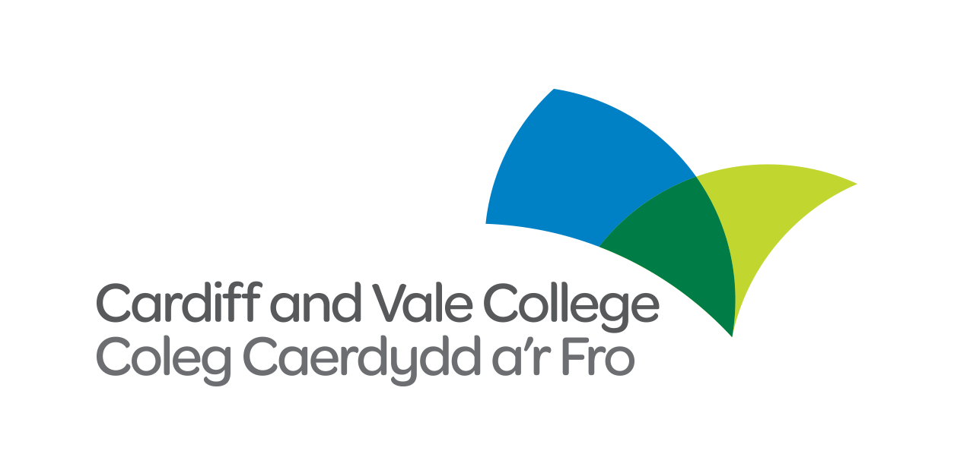
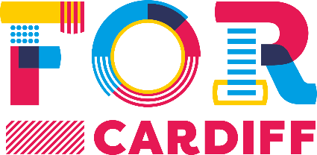

FREE TRAINING OPPORTUNITIES
In partnership with Cardiff and Vale College, FOR Cardiff are pleased to offer the following training opportunities completely free of charge to our members.
If you would like to see additional courses on offer please feel free to make a suggestion to the FOR Cardiff team.
To book your spot on any course please email emily@forcardiff.com

The current course schedule includes:

First Aid at Work
18th April
8th May
5th June
15th July
7th August
5th September
3rd October
6th November
4th December
22nd January
19th February
19th March

Level 2 Food Hygiene
May 1st
July 17th
September 18th
November 13th

Fire Safety Training
May 15th
October 9th

Sales Training
April 20th
September 28th

Social Media Training
May 22nd
September 11th

Presentation Skills
June 27th
September 6th

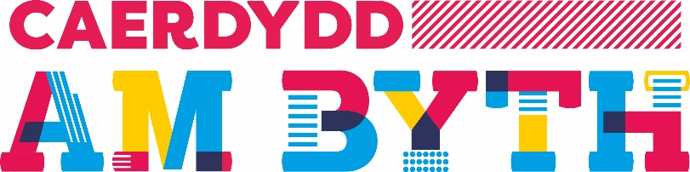

CYFLEOEDD HYFFORDDI AM DDIM
Mewn partneriaeth â Choleg Caerdydd a’r Fro, mae’n bleser gan FOR Cardiff gynnig y cyfleoedd hyfforddi am ddim canlynol i’n haelodau.
Os hoffech weld cyrsiau ychwanegol yn cael eu cynnig, mae croeso i chi wneud awgrym i dîm FOR Cardiff.
I archebu eich lle ar unrhyw gwrs anfonwch e-bost i emily@forcardiff.com

Mae amserlen bresennol y cyrsiau’n cynnwys y canlynol:

Cymorth Cyntaf o fewn y safle Gwaith
Ebrill 18fed
Mai 8fed
Mehefin 5ed
Gorffennaf 11eg
Awst 7fed
Medi 5ed
Hydref 3ydd
Tachwedd 6ed
Rhagfyr 4ydd
Ionawr 22ain
Chwefror 19eg
Mawrth 19eg

Hylendid bwyd lefel 2
Mai 1af
Gorffennaf 17eg
Medi 18fed
Tachwedd 13eg

Hyfforddiant Diogelwch Tân
Mai 15fed
Hydref 9fed

Hyfforddiant Gwerthiant
Ebrill 20fed
Medi 28fed

Hyfforddiant gwefannau cymdeithasol
Mai 22ail
Tachwedd 11eg

Sgilliau cyflwyniad
Mehefin 27ain
Medi 6ed

